1. Problem + Target Users
Many students have limited English vocabulary, while vocabulary learning in schools still relies heavily on rote memorization, word lists, and repetitive exercises. These methods can feel dull and may help students remember a word temporarily without teaching them how to actually use it in a sentence or real-life context.
This creates two major problems. First, students may recognize the meaning of a word but struggle to use it correctly. Second, repetitive memorization can reduce students’ motivation and may not support long-term vocabulary retention.
Our primary learners are students in Grades 3–8, approximately ages 8–14. Teachers are the secondary users: they need a fast way to turn their own word lists into a classroom activity without asking every student to create an account.
The project is designed to help students learn new and increasingly academic English vocabulary in a more engaging and meaningful way.
The target learning outcome is not only recognizing a definition. Students should be able to infer a word’s meaning, use the word in an original sentence, revise that sentence after feedback, and remember the word later.
Instead of simply asking students to memorize definitions, the platform allows them to see vocabulary visually, understand it in context, use it to form sentences, and receive immediate feedback.
Core problem: How can we transform vocabulary learning from passive memorization into an engaging process of understanding, applying, and receiving feedback?

2. Demo / Functionality
Step 0: Teacher Setup
Teachers choose a vocabulary set and difficulty level, optionally import their own words, and start a classroom session through a shared link or classroom display. The setup is intentionally low-friction so that the platform can be used for a short lesson, a group activity, or independent practice.
Step 1: Learn the Vocabulary
Students first encounter target vocabulary with visual materials. For example, instead of only seeing the word “observatory” and its definition, students can also see an engaging image representing an observatory.
The purpose is to help students infer the meaning of unfamiliar vocabulary through visual clues and context.
The visual clue appears before students are expected to rely on a translation. Students can make a prediction, reveal the meaning when necessary, and then connect the word to the image and the campus setting.
Students can also tap the speaker icon to hear the pronunciation of each target word, helping them connect its written form, visual meaning, and spoken form before using it in a sentence.
Step 2: Enter the Campus-Building Game
Students then enter a virtual campus-building activity. Different vocabulary words are connected to campus facilities such as an observatory, auditorium, cafeteria, dormitory, or laboratory.
To construct these buildings, students must complete English sentence tasks using the target vocabulary.
Step 3: Form a Sentence
Students create their own sentence using the target word in a campus-related context.
They can type the sentence or say it aloud using the speech-to-text function.
Students who need additional support can use sentence-structure hints. For example, the system might provide a structure such as “Students can ______ in the ______.”
Step 4: Receive AI Feedback
The AI checks the student’s sentence and identifies syntax or grammar problems.
Instead of only telling the student that the answer is wrong, the system shows where the mistake occurs and provides a corrected version or explanation.
The feedback is tied to the student’s own attempt. It is intended to be short, age-appropriate, and actionable rather than a replacement for the student’s thinking.
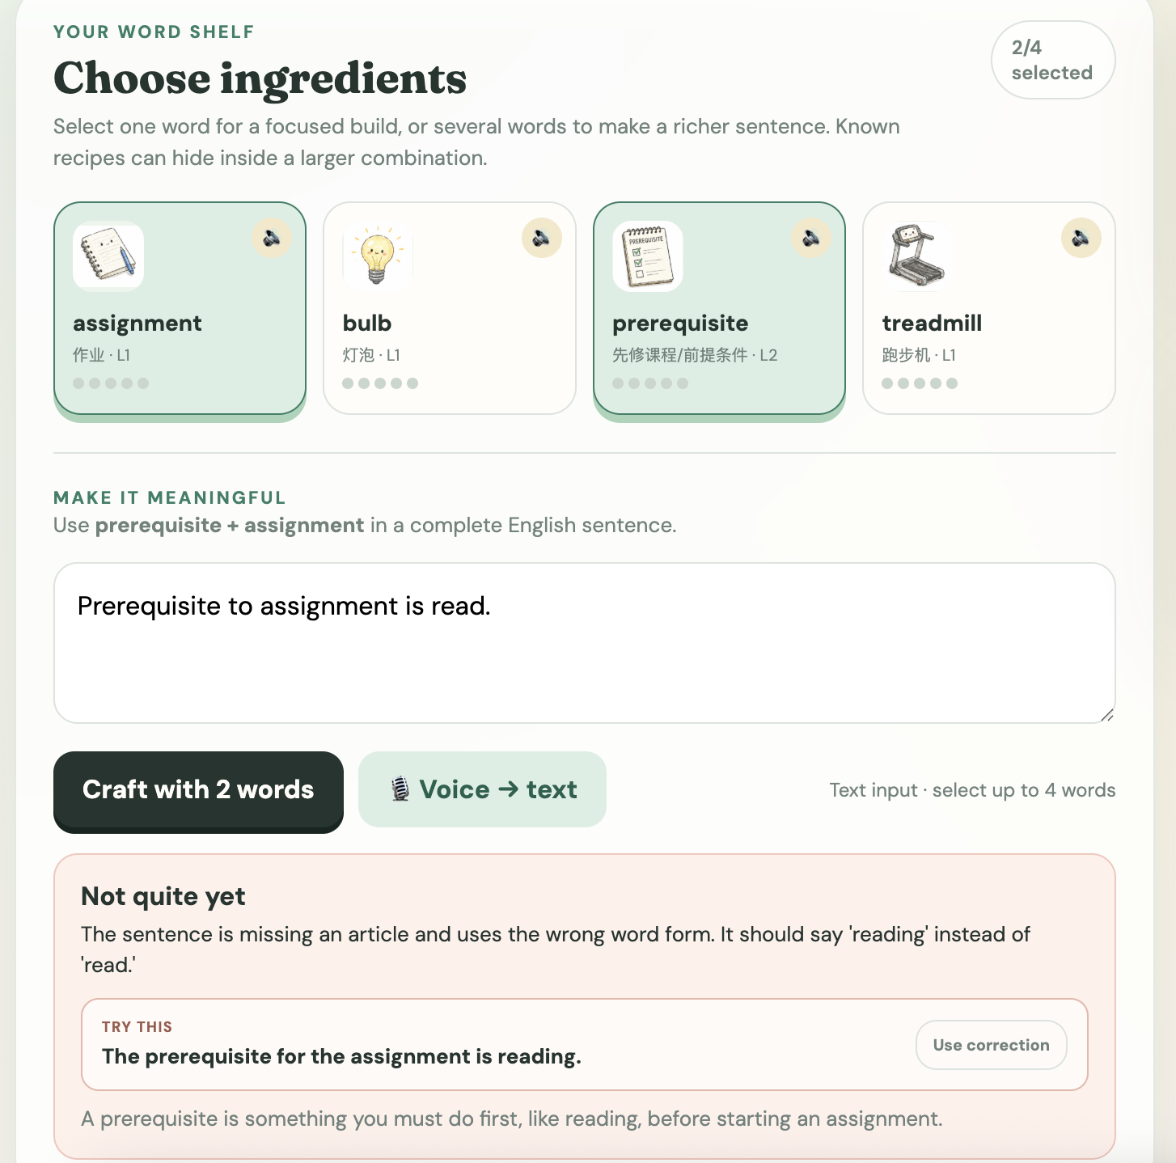
Figure 3. Sentence production and safe feedback fallback. The student combines “prerequisite” and “assignment,” receives a targeted grammar suggestion.

Step 5: Continue Building
When students successfully complete the language task, they can continue developing their virtual campus.
This connects vocabulary learning with visible progress and gives students a clear reason to use English.

3. AI Integration
AI Function 1: Grammar and Syntax Feedback
The prototype integrates an AI API into the platform to analyze students’ sentences.
The AI identifies grammar and syntax errors, provides corrections, and helps students understand where their sentence went wrong.
This creates a more personalized learning experience because different students receive different feedback depending on the mistakes they make.
The learning sequence is designed as:
Student thinks → Student produces a sentence → AI analyzes → Student revises.
The AI does not generate the original sentence for the student. It supports learning after the student has made an attempt, and the student remains responsible for deciding how to revise the sentence.
AI Function 2: AI-Generated Visual Materials
AI is also used to help teachers generate cute and engaging vocabulary illustrations.
Some advanced vocabulary can be difficult for younger students to understand through definitions alone. Visual materials help students connect a word with its meaning and context.
For example, instead of only reading the definition of “auditorium,” students can see an illustration of an auditorium and use the visual information to infer its meaning.
This also saves teachers time because they do not need to manually search for or design every vocabulary image.

4. Educational Mechanism
Mechanism 1: Gamification and Context-Based Learning
The platform combines gamification with contextual learning.
Students do not simply memorize a word and answer a multiple-choice question. They must actively use vocabulary to achieve a goal inside the game.
For example, if a student wants to build an observatory, they must use the word “observatory” correctly in a sentence.
The learning process therefore becomes:
Learn the word → Understand the context → Use the word → Build something.
This gives vocabulary a clear purpose and encourages students to actively apply what they have learned.
Mechanism 2: Visual Vocabulary Learning
Vocabulary is presented together with visual information.
Instead of immediately giving students a translation, the platform encourages them to observe the image and infer the meaning of the word.
This helps connect the written word, visual representation, meaning, and context.
Mechanism 3: Differentiated Learning
Students have different vocabulary abilities, so the same word list may not be appropriate for everyone.
Teachers can define the difficulty level of vocabulary beforehand.
The system can then provide vocabulary that matches the learner’s current level.
For example, a teacher can begin with foundational words, move to everyday and school vocabulary, or assign more precise academic vocabulary. A mixed setting can also support a class with different proficiency levels.
In future versions, the platform could also automatically adjust difficulty according to student performance.
Mechanism 4: Individualized Feedback
Different students make different language mistakes.
AI allows each student to receive individualized feedback immediately after submitting a sentence.
Students can clearly see what they wrote, which part is incorrect, and how they can improve it.
This turns mistakes into learning opportunities instead of simply marking answers as wrong.
Mechanism 5: Sentence Scaffolding
Some students may understand the meaning of a word but still struggle to form a complete English sentence.
For these students, the platform provides optional sentence structures.
For example:
“The ______ is next to the ______.”
“Students can ______ in the ______.”
These structures help lower-proficiency students participate in the activity while still requiring them to produce their own language.
As students improve, the amount of support can be reduced.
Mechanism 6: Individual and Group Learning Modes
The platform supports different classroom situations.
In individual mode, students independently learn vocabulary, form sentences, and receive personalized AI feedback.
In group mode, the teacher can display the game on a large classroom screen. Students form teams, discuss a sentence together, and give their answer orally.
The speech-to-text function can then convert the spoken sentence into text for evaluation.
This allows the platform to be used even when a classroom does not have one device for every student.
Mechanism 7: Low-Friction Classroom Use
The basic version of the system does not require students to create individual accounts.
Students can join through a shared classroom link or participate from a teacher-controlled screen. This makes it easier for teachers to start an activity quickly and also reduces unnecessary collection of student information.

5. Real-User Testing / TRL Evidence
The project has already moved beyond the idea stage and currently has a functional web prototype.
The prototype includes vocabulary learning activities, the campus-building game, AI-generated images, AI grammar feedback, speech-to-text input, vocabulary difficulty levels, sentence scaffolding, and both individual and group learning modes.

Prototype Interface Examples
The live prototype illustrates the intended classroom flow: teachers configure a round, students select illustrated vocabulary, produce a meaningful sentence, and use progress on a shared campus map as a visible reason to keep learning. These screenshots are product evidence, not outcome evidence; learning claims still require the real-user testing described below.
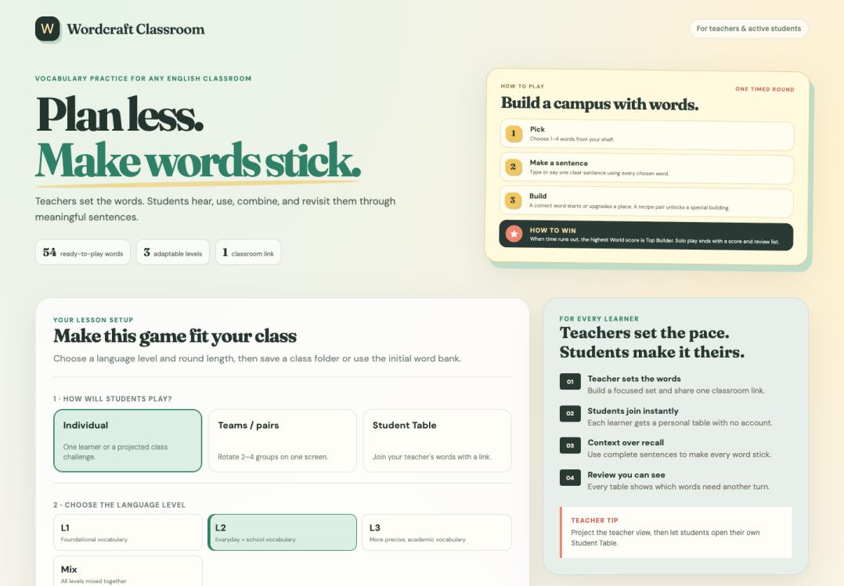
Figure 2. Teacher lesson setup with classroom mode, language-level, and round configuration controls.
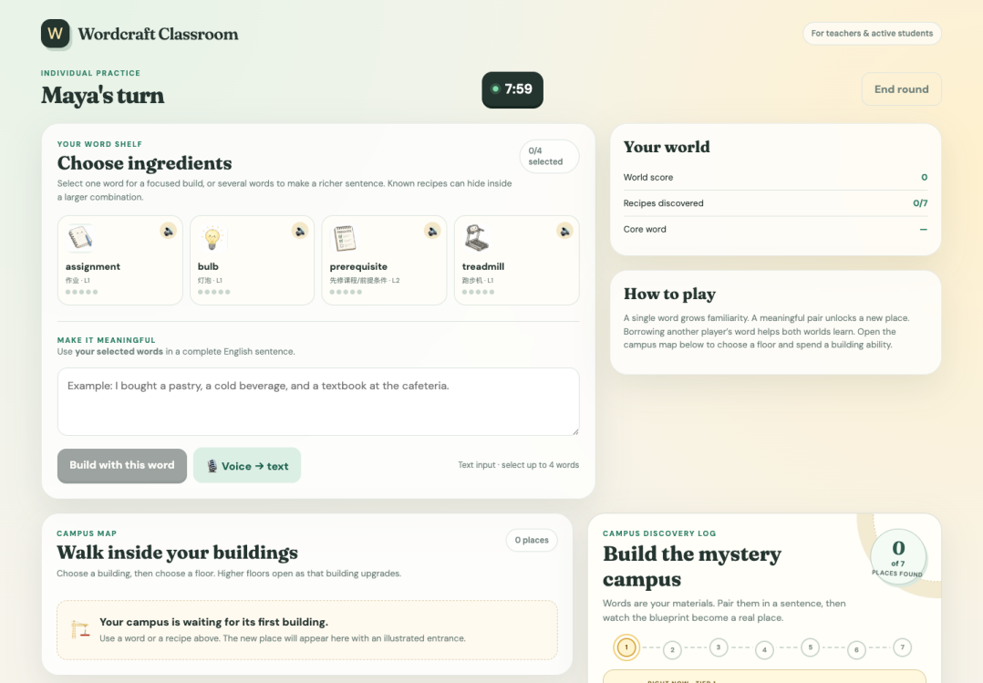
Figure 3. Student practice view with illustrated word cards, pronunciation audio, sentence input, and live progress indicators.

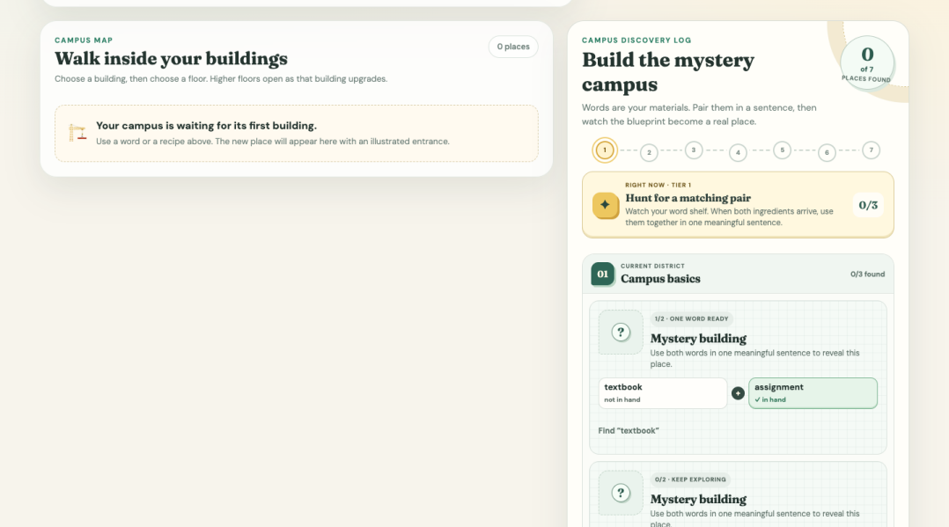
Figure 4. Campus map and discovery log that turn sentence use into visible building and mystery-campus progress.
The next stage is getting feedback from teachers.
Student feedback: [INSERT]
Teacher feedback: [INSERT]
The purpose of this testing is not only to demonstrate that the technology works, but also to determine whether it is a practical way to assist teachers in real classrooms.

6. Innovation vs. Existing Tools
Many existing vocabulary-learning tools focus on flashcards, definitions, spelling, repetition, or multiple-choice exercises.
Grammar tools usually correct writing after students have already completed a piece of work, while general AI chatbots are not specifically designed around a structured vocabulary-learning process.
Our project combines these different functions into one learning system.
The learning process is:
Vocabulary → Visualization → Context → Sentence Production → AI Feedback → Game Progress.
Students do not receive progress simply by recognizing the correct definition. They have to actively use the vocabulary.
Another important difference is that the vocabulary exists inside one connected environment. Words such as “observatory,” “auditorium,” “cafeteria,” and “dormitory” all become part of the same virtual campus.
The innovation is therefore not simply that the project uses an AI API.
The innovation lies in how AI is embedded into a structured educational mechanism that combines visual inference, gamification, contextual learning, sentence production, revision, personalized feedback, differentiation, and teacher control.
The key difference is the learning unit: students progress by using and improving a word, not merely by recognizing its definition. The campus gives that language work a visible purpose, while the teacher remains in control of the vocabulary and learning goals.

7. SDG Impact
The project primarily contributes to SDG 4: Quality Education.
One challenge in traditional classrooms is that teachers cannot always provide immediate individual feedback to every student.
For example, one teacher may have twenty or thirty students, each producing different sentences and making different grammar mistakes.
AI makes individualized feedback more scalable.
The platform can provide immediate language feedback, differentiated vocabulary, sentence-building support, independent practice, and engaging classroom activities.
The group mode also makes the system more accessible because teachers can use one large screen instead of requiring every student to own an individual device.
The long-term goal is to make personalized English-learning support more accessible to students with different ability levels and different levels of access to educational resources.
Possible impact indicators include vocabulary improvement, sentence accuracy, vocabulary retention, successful revision after feedback, student engagement, teacher time saved, accessibility of group mode, and number of students reached.
Any impact claim should be based on pre-test, post-test, delayed-test, usability, and teacher-observation data rather than on completion counts alone.

8. Market / Business Model
Our initial target market is upper-elementary and middle-school English education.
B2C Model: Students and Parents
Individual learners could access a free basic version of the platform.
The free version could include basic vocabulary sets, a limited number of campus-building activities, and basic AI feedback.
A premium version could provide larger vocabulary libraries, personalized vocabulary levels, adaptive review, learning history, and additional AI-generated materials.
B2B Model: Schools, Teachers, and Tutoring Programs
Schools and teachers could use a classroom version of the platform.
Teachers could define vocabulary lists, control word difficulty, use the group game mode, monitor student progress, and identify common errors.
Future versions could also include a teacher dashboard for assignments, class performance, and learning analytics.
The platform is designed to support teachers rather than replace them.
Teachers remain responsible for choosing learning objectives and vocabulary, while AI helps provide scalable materials and individualized feedback.

9. Responsible AI
Responsible AI is especially important because the target users include children.
Principle 1: AI Supports Thinking Instead of Replacing It
Students must first attempt their own sentence before receiving AI feedback.
The system does not encourage students to ask AI to complete the learning task for them.
Principle 2: Teacher Control
Teachers can define the vocabulary, difficulty level, and learning objectives.
AI supports these decisions rather than controlling the curriculum independently.
Principle 3: Data Privacy
The basic classroom experience does not require every student to create an account.
This reduces unnecessary collection of personal information, especially for younger users.
Principle 4: AI Accuracy
Generative AI may occasionally produce incorrect feedback or unsuitable content.
Therefore, AI responses should be limited to specific educational tasks, and teachers should be able to review important learning materials.
Principle 5: Age-Appropriate Content
AI-generated images and explanations should remain appropriate for younger learners and should avoid irrelevant or unsafe content.
Principle 6: Human Review and Minimal Data
AI feedback should support classroom learning rather than function as an unquestionable final grade. Teachers and students should be able to question or report unclear feedback, and important materials should be reviewed before classroom use. The system should collect only the information needed for the activity, avoid storing student audio by default, and present results in aggregate whenever individual identification is not necessary.
Principle 7: Clear System Boundaries
The interface should make clear when feedback comes from an AI service, a simple practice check, or a teacher. If the AI service is unavailable or its response is uncertain, the platform should explain the limitation and let the student continue safely without presenting the result as authoritative.
Our main Responsible AI principle is:
AI should increase students’ ability to learn independently rather than increase their dependence on AI.

10. Roadmap / Team
Phase 1: Functional Prototype
The current prototype includes the web-based learning platform, vocabulary system, campus-building game, AI-generated images, AI grammar feedback, speech-to-text, sentence scaffolding, difficulty levels, and classroom learning modes.
Phase 2: Adaptive Learning
The second version tracks vocabulary familiarity and repeated grammar mistakes.
The system would automatically adjust vocabulary difficulty, review frequency, and sentence support according to individual learner performance.
Phase 3: Real-User Testing
The next priority is to test the system with students in the target age group.
We will conduct pre-tests and post-tests, collect student and teacher feedback, evaluate the accuracy of AI feedback, and identify usability problems.
Testing is feasible because I attend a school with both primary and middle school departments. I can reach out to teachers in these departments for support in conducting the study.
Phase 4: Teacher Dashboard
Future development could allow teachers to upload their own vocabulary lists, define word levels, assign activities, monitor class progress, and identify common student mistakes.
Phase 5: Scaling
After the learning effectiveness has been validated, the platform could be introduced to more schools, tutoring programs, after-school programs, and English teachers.
The project is currently student-led and combines interests in education, curriculum design, game-based learning, and AI.
In the future, collaboration with teachers, students, educational researchers, and technical mentors can help improve the educational design and reliability of the platform.
Long-Term Vision:
Our goal is not to create another vocabulary memorization website or another general AI chatbot.
Our goal is to create a learning environment where students learn a word, understand it visually, use it meaningfully, receive personalized feedback, and apply it again through play.
Learn the word → Use the word → Get feedback → Build with the word.

Source: Wordcraft Classroom live prototype, https://wordcraftedu.innolearning.cn/ (accessed 13 September 2026).

